**C lass:** Final Year (Computer Science and Engineering)

**Year:** 2022-23 **Semester:** 1

**Course:** High Performance Computing Lab

**Practical No. 11**

**Exam Seat No:**

2019BTECS00033 – Teknath Jha

**Problem Statement 1:**

Q1. Execute the MPI program (Program A) with a fixed size broadcast. Plot the performance of the broadcast with varying numbers of processes (with constant message size). Explain the performance observed.

**Screenshot #:**

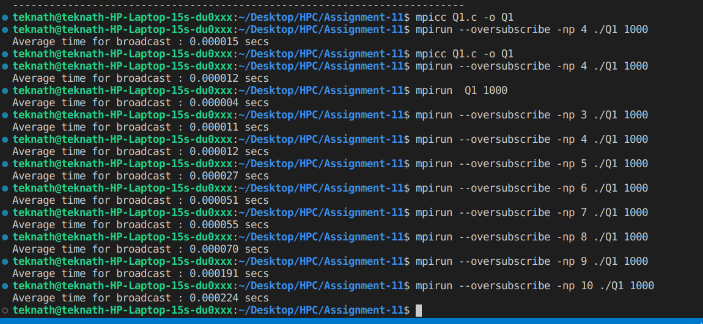

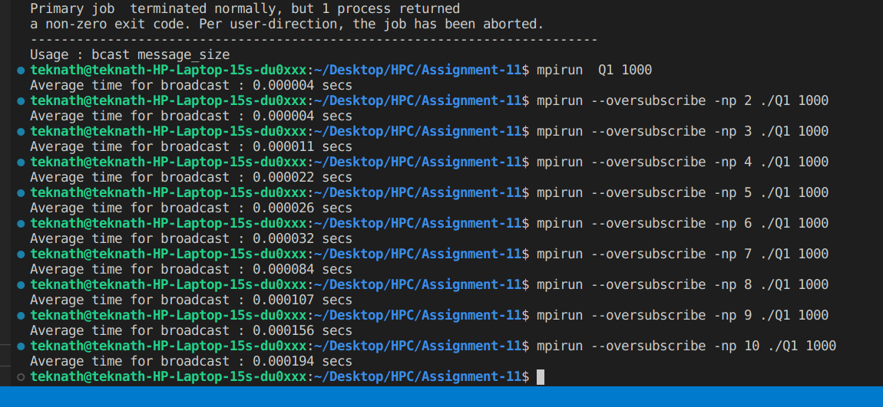

**Analysis :**

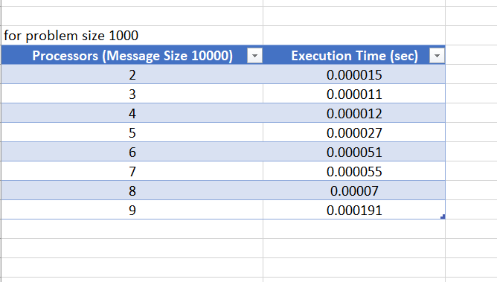

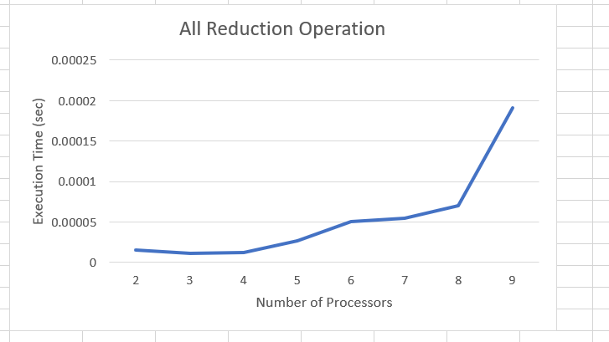

**So, here as problem size is fixed and number of processes is consistently increasing and we found that improvement in performance is seen as less but after some point that becomes time consuming due to overhead added here .**

**Second part :**

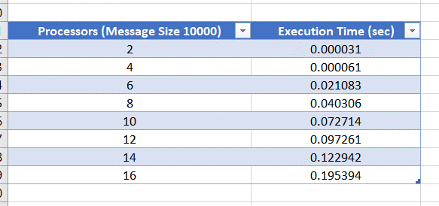

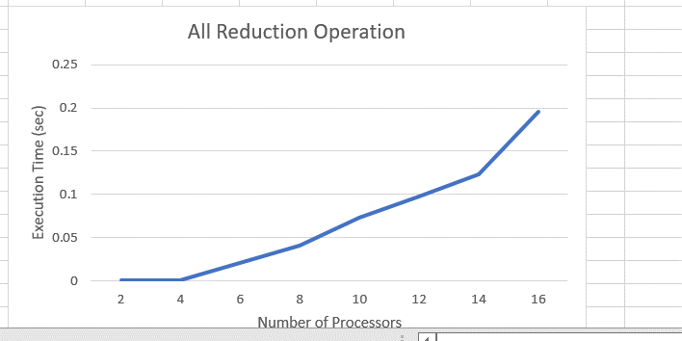

**Problem Statement 2:**

. Repeat problem 2 above with varying message sizes for reduction (Program B). Explain the observed performance of the reduction operation.

**Screenshot #:**

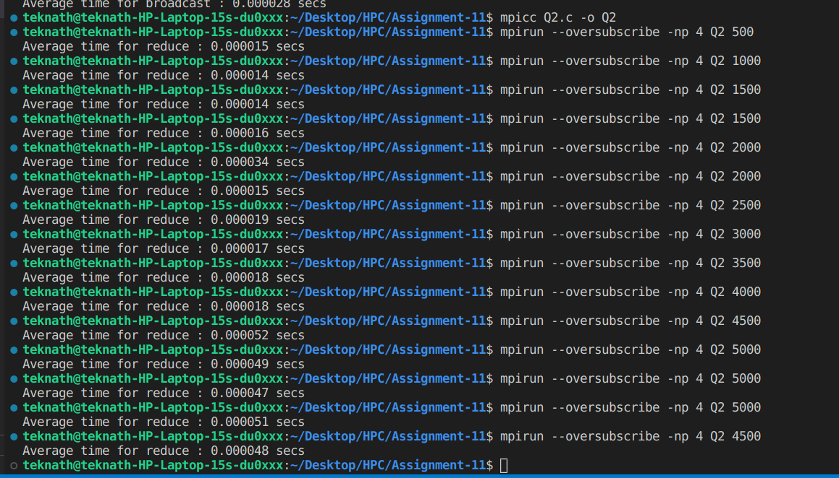

**Analysis :**

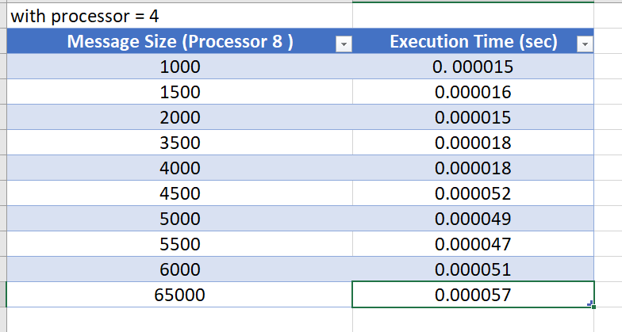

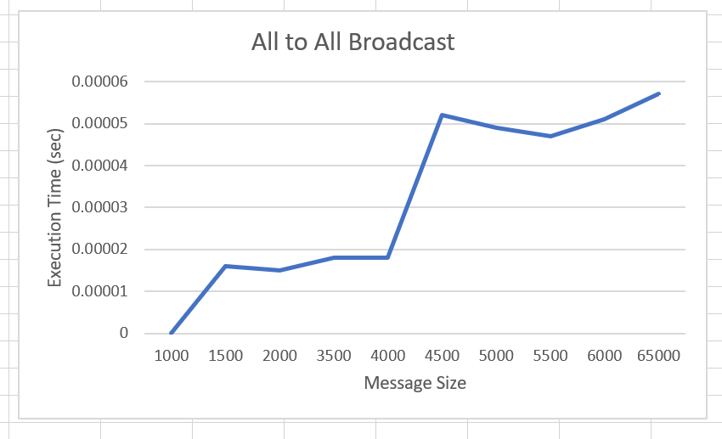

**For same number of processors size of problem distribution depends the most .**

**Like here for p=4 whenever problem size changes it changes its behaviour and after some point its performance will reduce as compared to initial.**

**Second part :**

